Software Design Document
<Project Title>



Submitted by
<Student Name (Muhammad Sajid)>

Submitted to
<Sir Muzammil-ur-Rehman>

Department of Information Technology
Faculty of Computing
The Islamia University of Bahawalpur

Summery
Here the author will write summery of the document. They can provide a brief of the background, their design considerations, website architecture and

Table of Content

- Website Architecture
SRMS website usually 3-tier architecture follow karti hai:

🔹 1. Presentation Layer (Frontend)
User Interface (UI)
Ye wo part hai jo users ko nazar aata hai.
Users:
- Admin
- Teacher
- Student
Technologies (example):
- HTML
- CSS
- JavaScript
- Bootstrap / React / Angular
- Functions:
- Login / Logout
- Result View
- Marks Entry Forms
- Dashboard

2. Application Layer (Backend / Business Logic)
Technologies (example):
- PHP / Java
- Python (Django / Flask)
- Node.js
Functions:
- User Authentication
- Marks Calculation (GPA, CGPA)
- Role Management (Admin, Teacher, Student)
- Validation of Data

🔹 3. Data Layer (Database)
Database Examples:
- MySQL
- PostgreSQL
- MongoDB
- Stored Data:
- Students Record
- Courses & Subjects
- Marks & Results
- Users Login Data

2️⃣ Website Architecture Diagram (Text Diagram)
┌─────────────────────────┐
│ Users │
│ Admin | Teacher | Student│
└────────────┬────────────┘
│
▼
┌─────────────────────────┐
│ Presentation Layer │
│ (HTML, CSS, JavaScript) │
└────────────┬────────────┘
│
▼
┌─────────────────────────┐
│ Application Layer │
│ (Business Logic) │
│ Authentication │
│ Result Processing │
└────────────┬────────────┘
│
▼
┌─────────────────────────┐
│ Database Layer │
│ (Student, Result Data) │
└─────────────────────────┘

3️⃣ Detailed Module Architecture

🔹 Admin Module
- Manage Students
- Manage Teachers
- Manage Courses
- Generate Reports

Teacher Module

Enter Marks
- Update Results
- View Student Performance

Student Module
- View Result
- Download Marksheet
- Profile Management

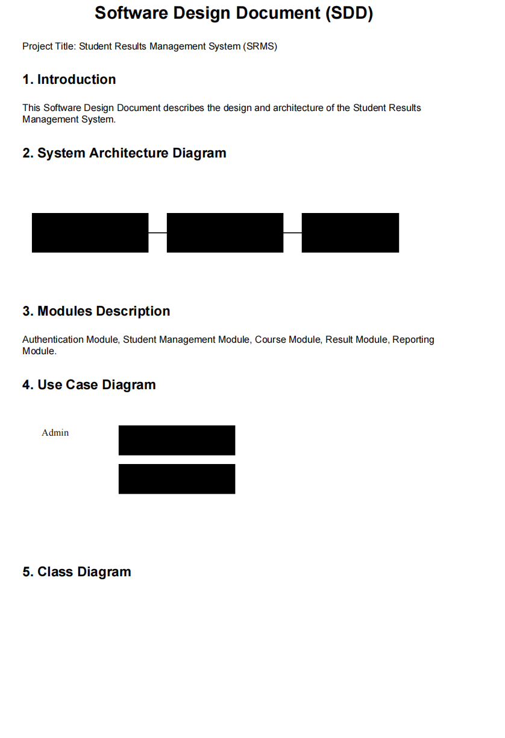
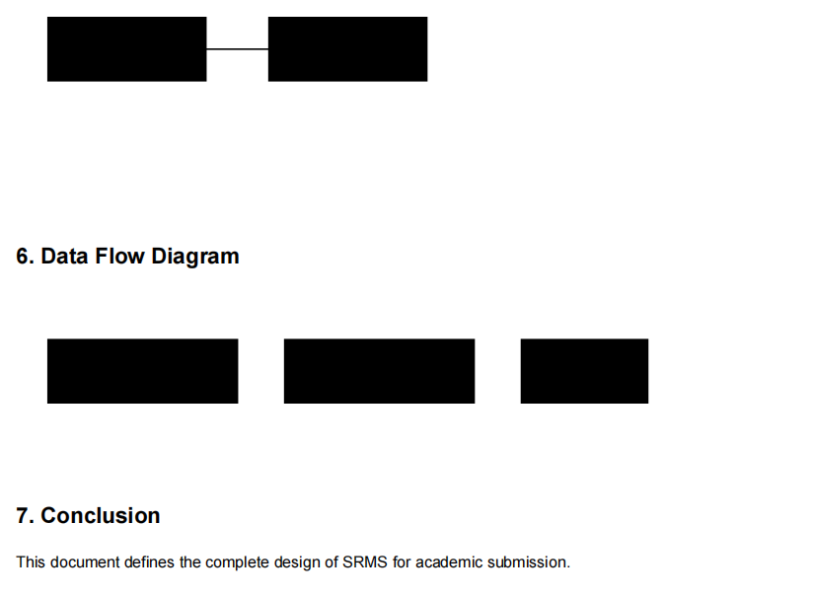

- User Interface
Overall design philosophy such as color scheme, font, design niche and screen constraints (if required then responsiveness or targeted screens size) will be discussed here. List of screens/pages will be provided and explain the data on each page/screen. List of controls (Textbox, Drop Down, Buttons etc.) on each page will be provided and explain the working of data. Also explain the input constraints.

